Curriculum vitae
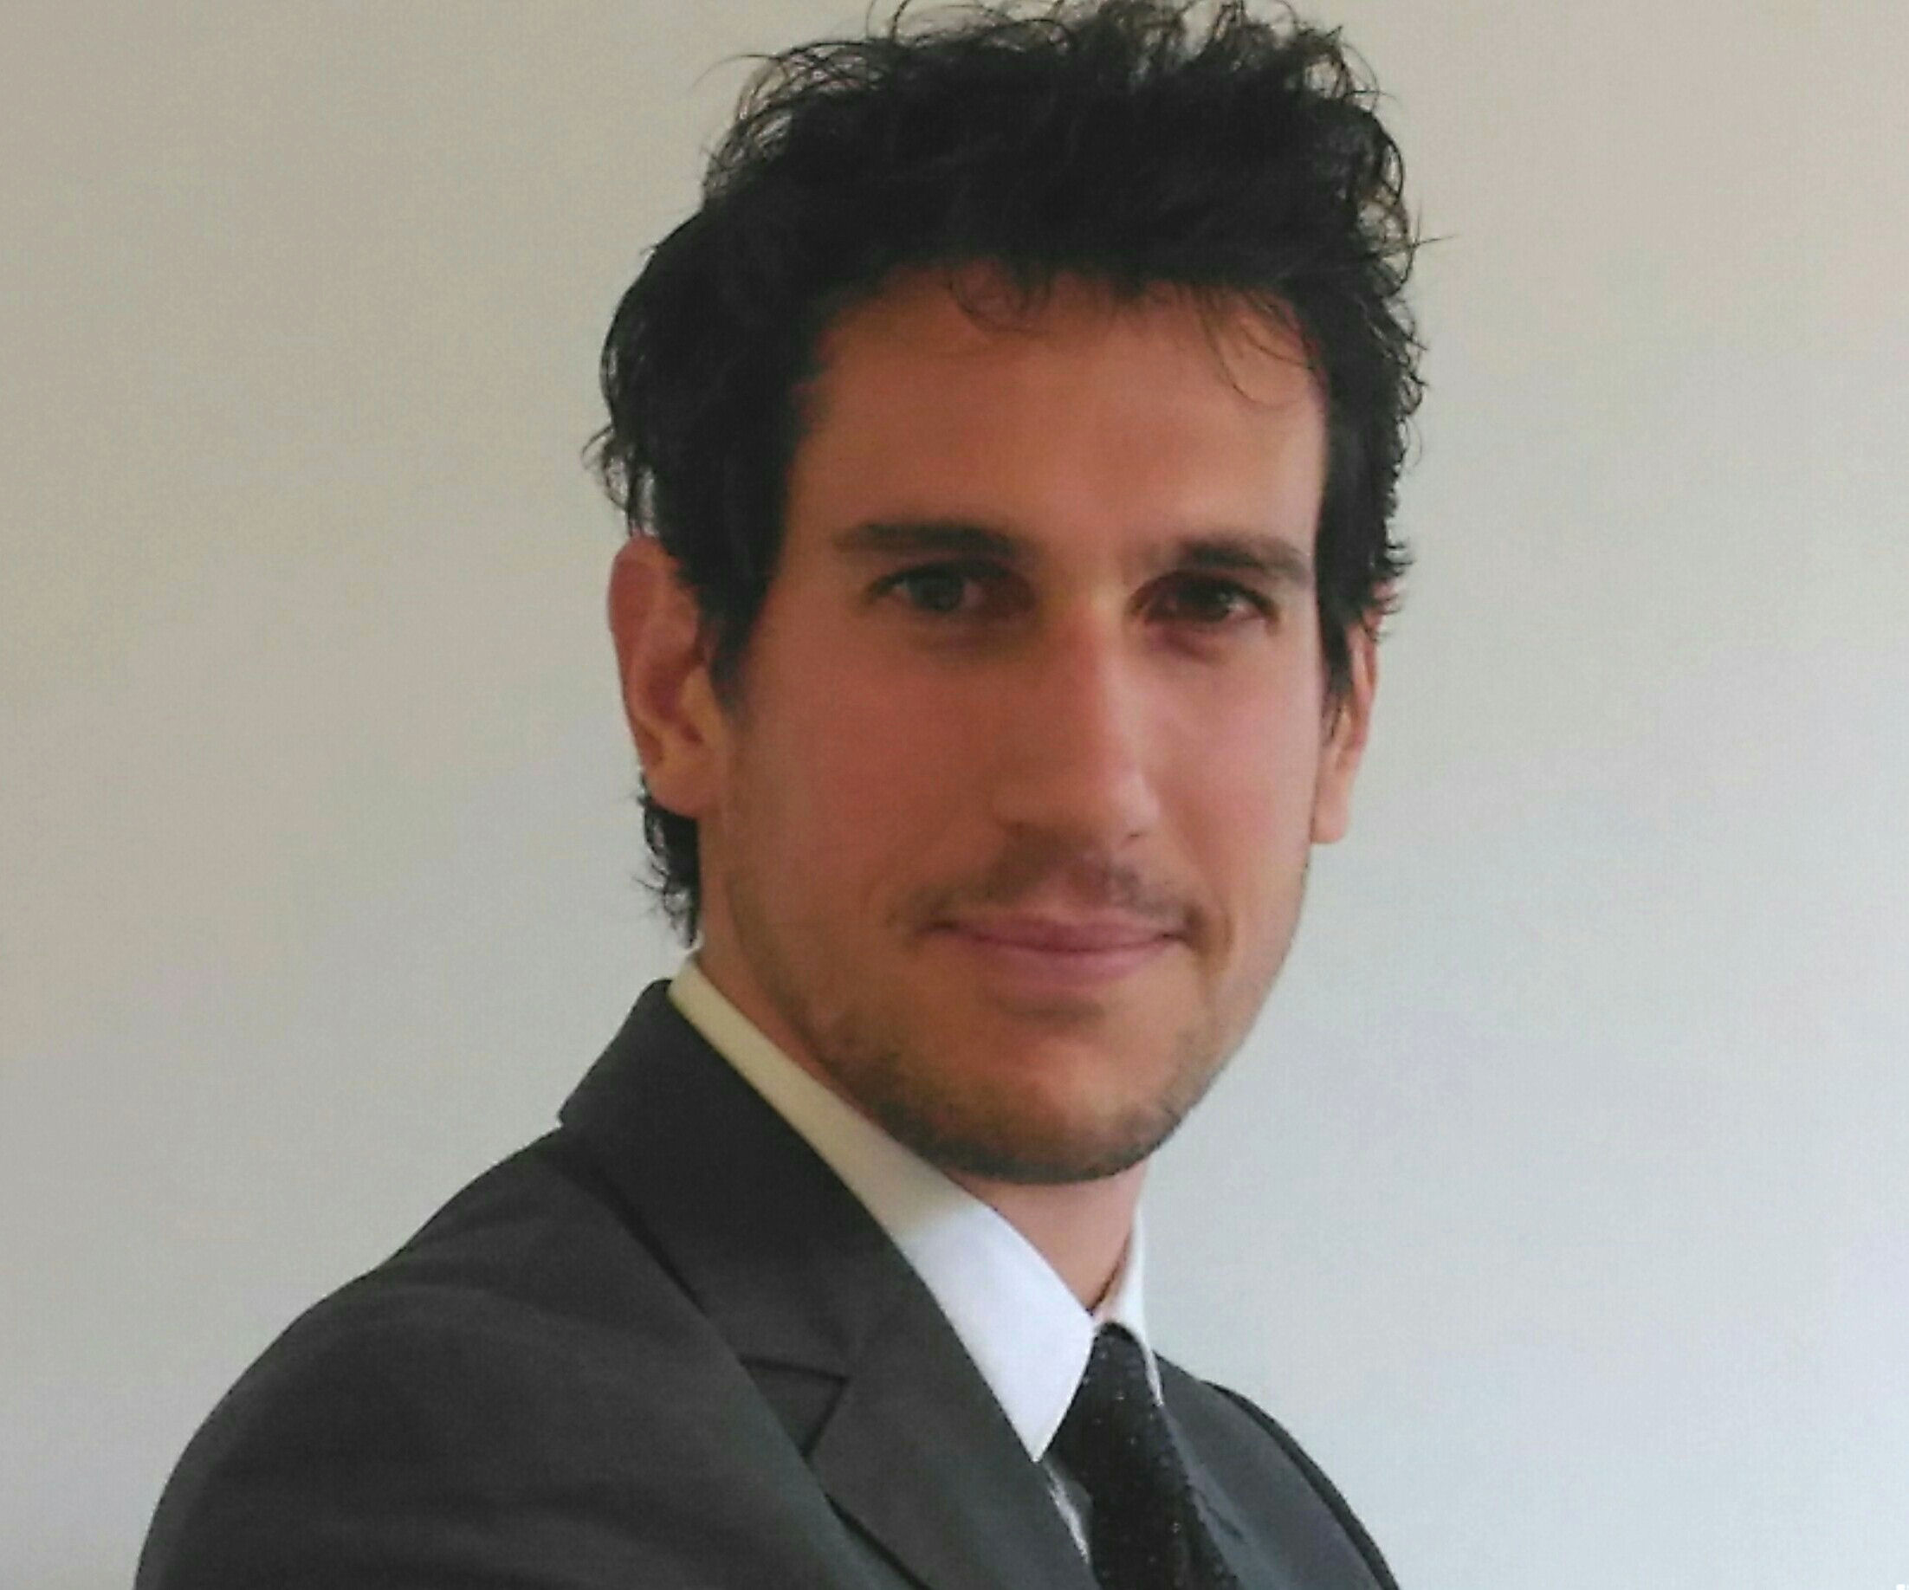
Matteo Monetti

Personal Information

First name / Surname: Matteo Monetti
Born on: 04/01/1990 in Rimini (IT)
Nationality Italian
Gender Male
E-mail: matteo.monetti@federmeccanica.it
Twitter @MatteoMonetti

Areas of Expertise

School-to-work transition and alternance programs
Labour and industrial relations
Continuous training
Industry 4.0
European funded projects management

Education and work experience

Graduated in Labour Relations at the Faculty of Economics Marco Biagi, University of Modena and Reggio Emilia.
Currently employed at Federmeccanica in the Education and Training Department.
Tasks:
- Development of the school work "alternance" program Traineeship (promoted by Federmeccanica and Ministry of Education).
- Organisation of vocational guidance project Eureka! Funziona!.
- Management of the european project "Industry4EU - Industry 4.0 for the future of manufacturing in the EU".
- Compared analysis about apprenticeship and continuous training.
- Researches about Industry 4.0 by way of the task force "Liberare l'ingegno".

